1)select acc.account_number,acc.customer_number,c.FIRSTNAME,c.lastname,acc.account_opening_date
from account_master acc left join customer_master c
on acc.customer_number=c.customer_number
order by account_number ;
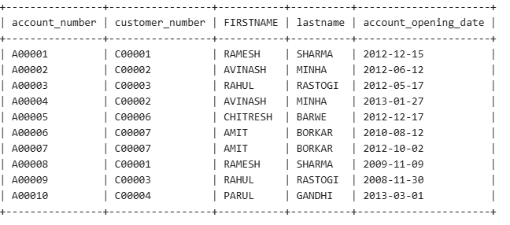
2) select count(CUSTOMER_CITY) as cust_count from customer_master
group by CUSTOMER_CITY
having CUSTOMER_CITY="DELHI";
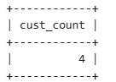

3) select acc.customer_number,c.FIRSTNAME,acc.account_number
from customer_master c left join account_master acc
on c.customer_number=acc.customer_number
where acc.account_opening_date>15
order by c.customer_number,acc.account_number;
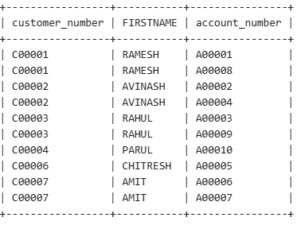

4)select count(customer_number) as Count_Customer from customer_master
where customer_number
not in (select customer_number from account_master);
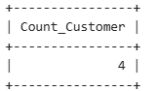

5)select t.transaction_type,count(t.transaction_type) as Trans_Count
from transaction_details t left join account_master acc
on t.account_number=acc.account_number
where acc.customer_number like '%001'
group by t.transaction_type
order by t.transaction_type;
